TO LET: METROPOLIS, 29 CHIAPPINI STREET
DE WATERKANT, GREEN POINT

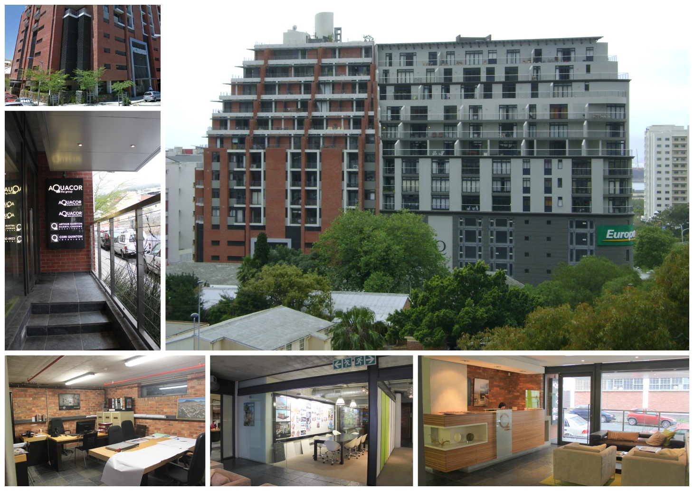

PROPERTY DESCRIPTION:

Ground Portion of Section 1, Metropolis, 29 Chiappini Street, De Waterkant

Metropolis is in close proximity to the prestigious & fashionable Cape Quarter Lifestyle Village as well as to numerous restaurants and cafes. It is also within easy walking distance to the City Centre and boasts easy access to the Atlantic Seaboard, N1 and N2 Highways, making it the ideal location for any business.

The ground floor office in the trendy Metropolis building is available from 1 March 2017. Prospective tenants have their own dry kitchen in the unit as well as having access to a shared reception area on the ground floor, bathroom and full (wet) kitchen complete with appliances. The space has a sought after industrial look and feel. Neighbouring tenants are Equator Accessories, Brenthurst Wealth Management and GenPrac. Office facilities include full power skirting for telephone & data cabling etc. as well as air-conditioning. A tenant installation allowance is available for leases signed for longer than 1 year.

SPECIFICATIONS:

 | SIZE | RENTAL
Ground Office | 206m² | R155/m²
Terrace | 10m² | R60/m²
Basement Parking |  | R1350/bay

OCCUPATION: March 2017

